**TITLE**

**File System Explorer**

A CAPSSTONE PROJECTREPORT

**Submitted to**

SAVEETHA SCHOOL OF ENGINEERING

**By**

Maka Gowri sankar (192210396)

Lekkala Kalyani (192224191)

Manne veera badru(192210158)

Supervisor

DR.S. VIRUSHABADOSS



SIMATS ENGINEERING

SAVEETHA INSTITUTE OF MEDICAL AND TECHNICALSCIENCES,

CHENNAI – 602 105

Abstract:

A File System Explorer is a fundamental component of modern operating systems, enabling users to interact with the hierarchical organization of files and folders stored on storage devices such as hard drives, solid-state drives, and networked drives. The primary purpose of a File System Explorer is to provide users with an intuitive graphical interface for browsing, organizing, searching, and manipulating files and directories

**GANTT CHART**

|  |  |  |  |  |  |  |  |  |  |  |  |  |  |  |  |
| --- | --- | --- | --- | --- | --- | --- | --- | --- | --- | --- | --- | --- | --- | --- | --- |
|  | Day 1 | Day  2 | Day  3 | Day  4 | Day  5 | Day  6 | Day  7 | Day  8 | Day  9 | Day  10 | Day  11 | Day 12 | Day  13 | Day 14 | Day  15 |
| Abstract and Introduction |  |  |  |  |  |  |  |  |  |  |  |  |  |  |  |
| Literature survey |  |  |  |  |  |  |  |  |  |  |  |  |  |  |  |
| Materials and Methods |  |  |  |  |  |  |  |  |  |  |  |  |  |  |  |
| Results |  |  |  |  |  |  |  |  |  |  |  |  |  |  |  |
| Discussion |  |  |  |  |  |  |  |  |  |  |  |  |  |  |  |
| Report |  |  |  |  |  |  |  |  |  |  |  |  |  |  |  |

**FLOWCHART:**

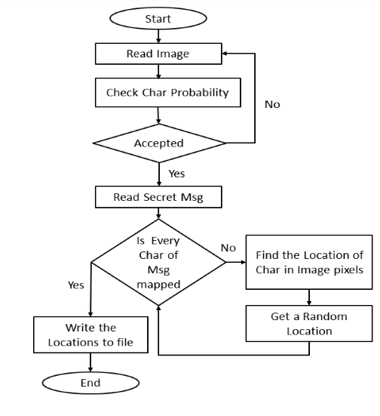

**INTRODUCTION:-**

In the digital age, where vast amounts of data are created, stored, and managed on computers and other electronic devices, the need for efficient file management tools has become paramount.

A File System Explorer, also known as a file manager or file browser, stands as a cornerstone application in modern computing environments. It provides users with a graphical interface to navigate, organize, and manipulate files and directories stored on their computer's file system.

At its core, a File System Explorer offers users a window into the hierarchical structure of files and folders that make up their storage drives. From the humble beginnings of command-line interfaces, file management has evolved into sophisticated graphical interfaces that empower users to interact with their digital content intuitively.

**Evolution of File System Exploration**

Early file managers were command-line based, requiring users to type commands to navigate through directories and perform file operations. However, with the advent of graphical user interfaces (GUIs), file management underwent a transformation, making it accessible to a wider audience.

The introduction of desktop environments like Microsoft Windows, Apple macOS, and various Linux distributions brought forth graphical file managers that allowed users to interact with files and folders using a mouse-driven interface. These file managers featured familiar paradigms such as drag-and-drop functionality, context menus, and visual representations of file systems.

**Key Features of a File System Explorer**

A File System Explorer encompasses a range of features designed to streamline file management tasks and enhance user productivity:

1. **Navigation**: Users can traverse through directories and subdirectories to locate specific files or folders within the file system hierarchy.
2. **File Operations**: Common file operations such as copying, moving, renaming, deleting, and creating files and folders are supported, providing users with essential tools for organizing their digital content.
3. **File Preview**: Many File System Explorers offer the ability to preview the contents of files directly within the interface, allowing users to quickly assess the nature of files without opening them in separate applications.
4. **Search Capabilities**: Robust search functionality enables users to locate files based on various criteria such as file name, file type, size, and modification date, among others.
5. **Customization Options**: Users can personalize the appearance and behavior of the File System Explorer, adjusting settings such as view layout, sorting preferences, and display options to suit their workflow.
6. **Integration with System Utilities**: Seamless integration with system utilities and external applications enables users to perform advanced file operations, manage file permissions, and execute file-related tasks efficiently.
7. **Cross-Platform Compatibility**: File System Explorers are often designed to be compatible with multiple operating systems and file systems, ensuring interoperability across diverse computing environments.

**OBJECTIVE:-**

1. **Facilitate File Navigation:** The File System Explorer allows users to navigate through the hierarchical structure of files and folders stored on their storage devices. Users can easily traverse directories, view folder contents, and locate specific files within the file system.
2. **Enable File Management Operations:** Users can perform common file management operations such as copying, moving, renaming, deleting, and organizing files and folders. These operations are essential for maintaining an organized and efficient file system.
3. **Provide File Preview:** The File System Explorer offers the capability to preview file contents directly within the interface. This feature allows users to quickly preview documents, images, videos, and other file types without the need to open them in separate applications.
4. **Support Search Functionality:** The File System Explorer includes powerful search capabilities that enable users to locate files and folders based on various criteria such as file name, file type, size, date modified, and content. This feature helps users quickly find specific files amid large volumes of data.
5. **Offer Customization Options:** Users can customize the appearance and behavior of the File System Explorer according to their preferences. They can configure view settings, sort files and folders, apply filters, and personalize the user interface to enhance their overall user experience.
6. **Integrate with System Utilities:** The File System Explorer seamlessly integrates with system utilities and external applications for performing advanced file operations, managing file permissions, and executing file-related tasks. This integration enhances the functionality and versatility of the File System Explorer.
7. **Ensure Cross-Platform Compatibility:** File System Explorers are designed to be compatible with various operating systems and file systems, ensuring interoperability across different computing platforms. This compatibility allows users to access and manage files across diverse environments.
8. **Enhance User Productivity:** By providing a user-friendly interface and robust set of features, the File System Explorer aims to enhance user productivity and efficiency in managing their digital assets. Users can perform file-related tasks more effectively, saving time and effort in their daily workflows

**LITERATURE REVIEW :-**

A comprehensive literature review on File System Explorers delves into a rich array of topics encompassing research, scholarly articles, and publications within the realms of computer science, human-computer interaction, and user experience design. Through an exploration of the evolution, design principles, user experiences, functionality, and emerging trends, such a review illuminates the multifaceted landscape of file management software.

File System Explorers have undergone a transformative journey from rudimentary command-line interfaces to sophisticated graphical user interfaces (GUIs) and web-based platforms. Tracing this evolution provides valuable insights into the progression of user interaction paradigms and technological advancements driving the development of file management tools.

Central to the discourse is the examination of user interface design principles that underpin File System Explorers. By scrutinizing aspects such as layout, navigation schemes, iconography, and affordances, researchers seek to elucidate the mechanisms through which users interact with and comprehend file structures.

An exploration of user experience research sheds light on the usability, efficiency, and satisfaction levels associated with File System Explorers. Through usability studies, user feedback mechanisms, and user-centered design approaches, scholars endeavor to enhance the overall user experience and optimize user workflows.

Functionality and feature analyses form a cornerstone of literature reviews, encompassing a wide spectrum of capabilities ranging from file navigation and management operations to search functionalities, customization options, and integration with system utilities. These investigations illuminate the diverse needs of users and the evolving landscape of file management requirements.

Security and privacy considerations constitute another critical dimension of literature reviews, encompassing discussions on file access controls, encryption mechanisms, permission management, and strategies for mitigating security vulnerabilities inherent in File System Explorers.Moreover, studies on cross-platform compatibility, emerging technologies, user preferences, and educational perspectives provide additional layers of insight into the dynamic interplay between File System Explorers and users across various contexts and environments.By synthesizing and analyzing existing literature in these domains, researchers and practitioners gain valuable perspectives on the design, functionality, usability, and impact of File System Explorers. Through a nuanced understanding of user needs, technological trends, and design principles, literature reviews contribute to the ongoing refinement and innovation of file management software, ultimately enriching user experiences and computational ecosystems.